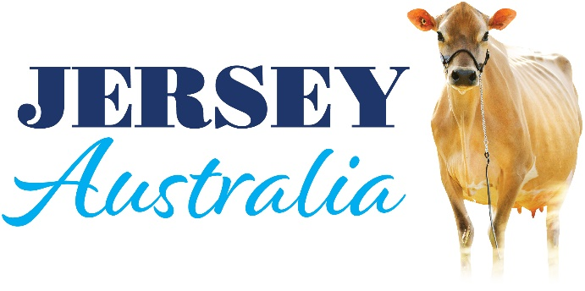

MEDIA RELEASE

Australian genetics to boom after World Dairy Expo

Australian Jersey genetics are on the cusp of a dramatic sales boom after a successful trade mission to the world’s largest dairy expo.

Jersey Australia led a joint trade site at World Dairy Expo in Madison Wisconsin, USA, that also included Genetics Australia and AgriGene.

Jersey Australia general manager Glen Barrett said the increase in product recognition after the 2022 was impressive.

“It was an extraordinarily positive outcome for what we are trying to achieve,” Mr Barrett said. “There was strong interest from farmers and resellers looking to stock products, which was really pleasing, and there were more people coming through the site and much greater interest from people wanting to know more about Australian product.”

The interest came not just from North America but also from South America, Africa, and Europe, and there was strong interest in heifers going into Sri Lanka and China.

“There is recognition of what the Australian Jersey offers,” Mr Barrett said. “We see it as the best Jersey in the world and that is starting to resonate with other markets. People are impressed with the strength and efficiency of the Australian Jersey cow and her capacity to produce in all farming conditions.”

The site was presented to show the quality of Australian cows in the paddock and Mr Barrett said the delegation plans to return next year to build on the momentum.

“In my view, we’re right on the cusp of a dramatic sales increase,” he said.

The delegation also got to see Australian genetics in action in the US market, including Bontino and ASKN daughters in the Expo show, a Bontino daughter which came third in her class and an ASKN embryo sell in the Top of the World Jersey Sale at the Expo, and an ASKN son is being sold in the USA and Canada.

Genetics Australia and AgriGene will follow up strong enquiries.

Genetics Australia export manager Rob Derksen said awareness of Australian product was very good in the US and international markets and the Expo site was helping to grow that reputation.

“I spoke to people from Costa Rica, Guatemala, Ecuador and other countries as well as from the US and Canada and the interest in very high,” Mr Derksen said. “There will definitely be more semen product going overseas.”

“Australian genetics have a good reputation and the Expo is the place to show that to the world.”

Mr Derksen also met with representatives from global herd improvement leader URUS Group LP, including the GENEX co-operative which joined Genetics Australia in a joint venture this year.

“We’re now following up opportunities in South Africa and South America,” he added.

Agri-Gene general manager Chris McIlroy said

FOR MORE INFORMATION
Glen Barrett 0418 466371

